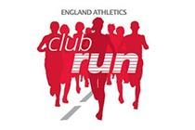
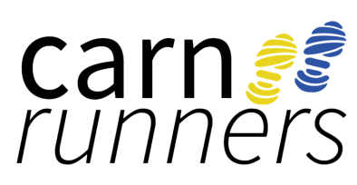

UKA CLUB RUN

What is Club Run?
- Three coach-led visits to your club over a 3 month period
- Three practical coach-led sessions, each lasting between 90 minutes to 2 hours
- An experienced and qualified coach associated with the England Athletics coach development programmes
- Focused and progressive sessions in line with the aspirations of the club’s runners and leading towards helping them prepare for a particular event or distance
- Endurance specific warm up and cool down session components
- Support and guidance for the club’s coaches and leaders
- The opportunity for informal discussion around key topics linked to training and race preparation

But what does that mean for you?
- We have been assigned a UKA Level 4 Coach, Pete Robins
- As a club we will train for the Mob Match Race (5 miles) on 25th November
- Pete has provided 3 different training schedules for the Mob Match, targeting finishing times 30-40mins, 40-50 mins, 50-60+ mins with defined sessions on 5 days per week – its only a guide and don’t worry if you can’t commit to 5 days, you can still do it!
- Run Leaders will be coordinating the training groups for each finish time, and there may be several groups per finishing band.
- Training Schedule to start w/c 16 September
- The main session will be on a Wed, when you will be able to feedback your previous weekly sessions to your Run Leader and adjust sessions accordingly.
- 3 Visits by Pete on a Wed Club night to take/assist with the training sessions and provide the opportunity for post-run Q&A

Let us know if you wish to participate
and get your Mob Match place via www.runbritain.com/race/falmouth-mob-match, as the race entries are selling fast.

There will be Prizes!

Any queries – please get in touch mailto:carnrunners@hotmail.co.uk

